Name: Daljeet Singh
Student ID: 3169763
PART - I
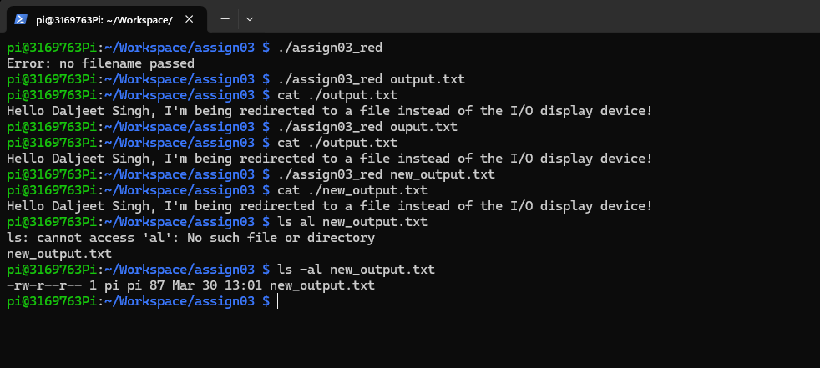

- What dup2( ) helped to achieve:
Ans: The dup2( ) system call allowed me to redirect standard output of the system to the input file. When the program uses printf(), the message is written into the file rather than displayed on the I/O devices.

- Benefits of the file descriptor duplication:
Ans: Duplicating file descriptors with dup2( ) provides a powerful way to manage I/O without modifying the source code. They allow a program to reuse standard operations like printf() and scanf() with files, devices without changing the rest of the code.

PART – II
Question 2:
Sometimes a consumer message appears before the matching producer message this occurs because the printf statements are located later in code. After the producer puts the items in the buffer, the schedular run a consumer immediately and the consumer can eat that item before the producer’s printf happens.

Question 3:
In the 0 producer and 3 consumer case, no real data will ever produced. In this program, the producer finish immediately and the main thread send items to the consumers.

Question 4:
In the 4 producers and 0 consumers case, producers produces data and stored in the buffer until the buffer becomes full. Once the buffer is full, any producer attempts to add more data will be blocked. Since no consumers exist to remove items the producers will remain blocked forever.

Question 5:
No argument passed:
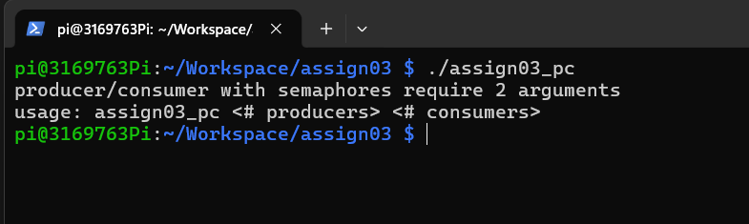
One argument passed:
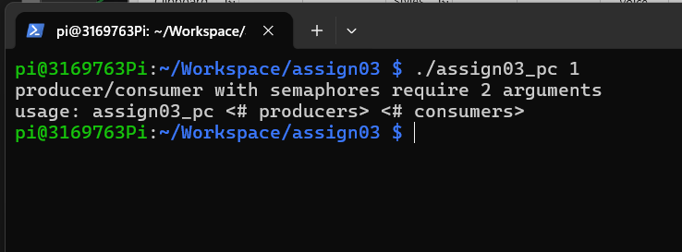

Producer 1 , consumer 2
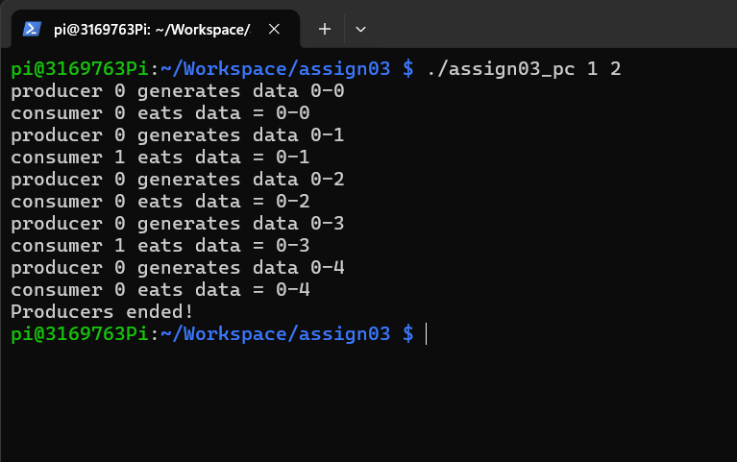

Producer 3, consumer 1
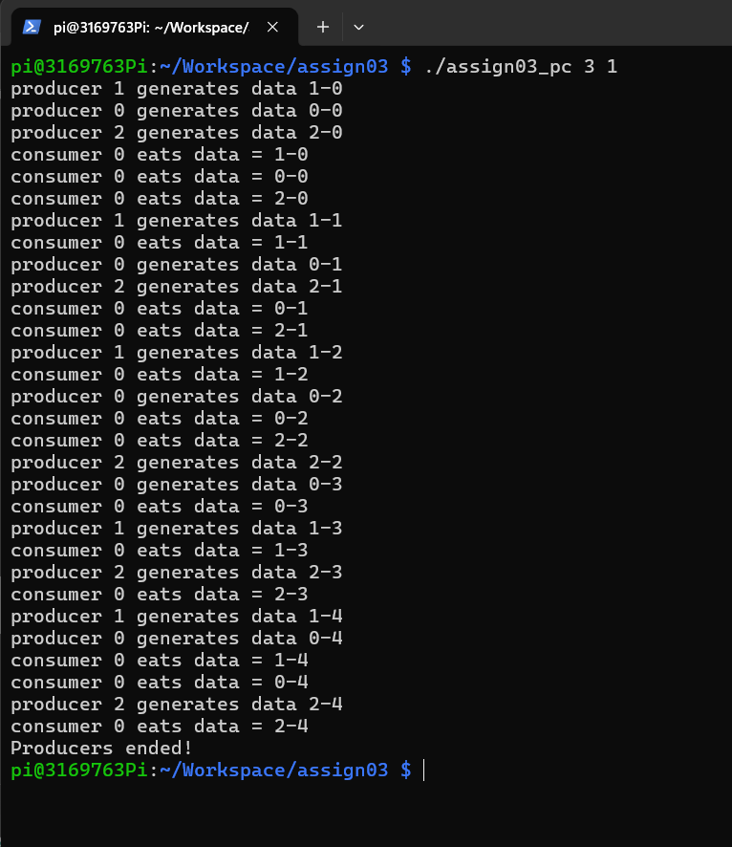

Producer 3 , consumer 4
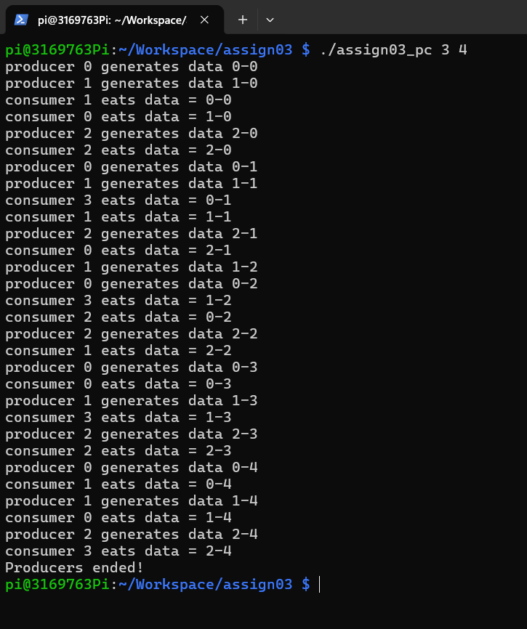

Producer 0 , consumer 3
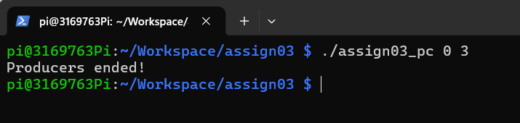

Producer 4, consumer 0
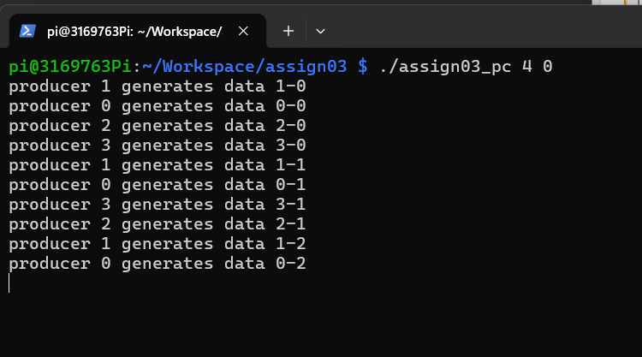

Producer 5, consumer 5
